Tutorial 17

Programming exercise 1 – ConnectionString and DbManager
- Make sure that WIUT.DAL project is selected in Solution Explorer. Go to Project => WIUT.DAL properties.
- Select Settings tab, add new setting:
  - Name: ConnectionString
  - Type: (ConnectionString)
  - Value: Data Source=WIUT.db
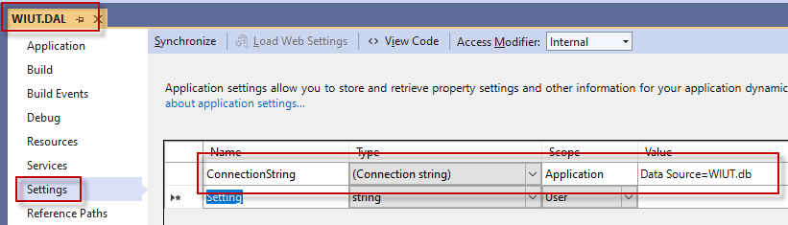

- In WIUT.DAL project add new class. Name it DbManager and make it public
public class DbManager

- Add using statement
using System.Data.SQLite;

- Create a protected read-only property that will return a connection with correct connection string.
protected SQLiteConnection Connection
{
get
{
return new SQLiteConnection(Properties.Settings.Default.ConnectionString);
}
}

- Update ApplicantManager and CourseManager to inherit from DbManager and update the methods with empty connection strings to acquire connection from the parent class property
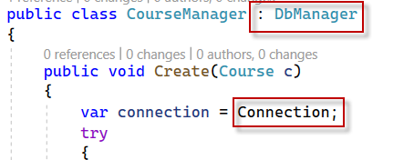

Programming exercise 2 – Updating settings
IMPORTANT: you don’t need this for your CW!

- Create FormLoad handler for parent form
- Find out how many courses we have by calling GetAll() function of CourseManager class
MessageBox.Show(new CourseManager().GetAll().Count.ToString());

- Run the project and see the result
- Add NuGet package called System.Configuration.ConfigurationManager to WIUT project
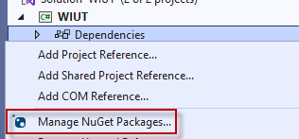
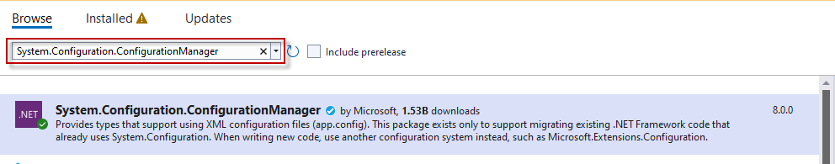
- Add new App.config file to WIUT project

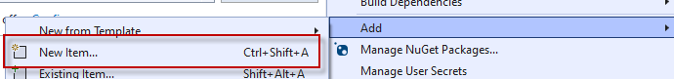
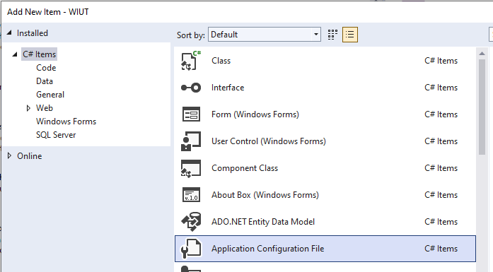

- Run your project and ensure that WIUT.exe.config if created in bin\Debug folder of WIUT project.
- Go to bin/Debug folder of your WIUT project and rename WIUT.db to some other name and run the exe in the same folder – the application will show an error message as it cannot find the database file anymore.
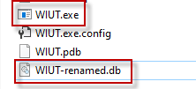

- Open app.config file in WIUT.DAL project and find the following section:
<connectionStrings>
<add name="WIUT.DAL.Properties.Settings.ConnectionString" connectionString="Data Source=WIUT.db" />
</connectionStrings>

- Open WIUT.exe.config file located in bin/Debug folder of your WIUT project. Paste the section outlined in the previous point anywhere before closing </configuration> tag. Change the name of the referenced DB file to the new name:
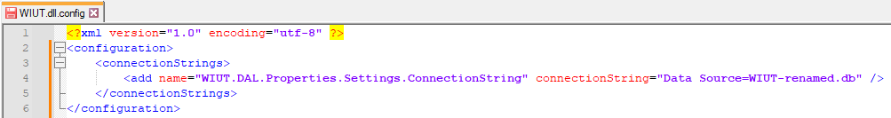

- Run WIUT.exe to ensure that the error is now gone

Programming exercise 4 – ByAttribute enumeration
- Create new class in WIUT.DAL project. Name it ByAttribute
- Create public enumeration, call it ByAttribute and add the following members
  - Name
  - Surname
  - DoB
  - Course
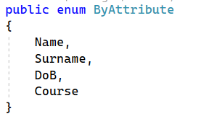

Programming exercise 5 – Sorting
- Add new class to WIUT.DAL, call it ApplicantManagerFunctions
- Make this class partial to ApplicantManager

partial class ApplicantManager

- Change the declaration of ApplicantManager class inside ApplicantManager.cs to be partial as well

public partial class ApplicantManager : DbManager

NOTE: if working with partial classes is too confusing for you, just add the following functions at the end of ApplicantManager.cs, having it in a separate file doesn’t change the functionality, it’s only about organizing your code.

- Create Sort function in ApplicantManagerFunctions file to enable sorting using IComparer. Use ByAttribute enumeration for selection of sort options

public List<Applicant> Sort(ByAttribute attribute)
{
switch (attribute)
{
case ByAttribute.Name:
break;
case ByAttribute.Surname:
break;
case ByAttribute.DoB:
break;
case ByAttribute.Course:
break;
}

//if we are here - something went wrong
return null;
}

- Add private class ByNameComparer inside ApplicantManagerFunctions.cs file:
private class ByNameComparer : IComparer<Applicant>
{
public int Compare(Applicant x, Applicant y)
{
return string.Compare(x.Name, y.Name);
}
}

- Populate corresponding clause in Sort function:
case ByAttribute.Name:
var result = GetAll();
result.Sort(new ByNameComparer());
return result;

Programming exercise 6 – Sorting via LINQ
- Create SortLinq function in ApplicantManagerFunctions.cs file to do sorting using LINQ to objects.

public List<Applicant> SortLinq(ByAttribute attribute)
{
switch (attribute)
{
case ByAttribute.Name:
return GetAll().OrderBy(a => a.Name).ToList();
case ByAttribute.Surname:
var result = from a in GetAll() orderby a.Surname select a;
return result.ToList();
case ByAttribute.DoB:
break;
case ByAttribute.Course:
break;
}

//if we are here - something went wrong
return null;
}

Programming exercise 7 – Searching
Create Search function in ApplicantManagerFunctions.cs file..
public List<Applicant> Search(string value, ByAttribute attribute)
{
switch (attribute)
{
case ByAttribute.Name:
return GetAll().Where(a => a.Name.Contains(value)).ToList();
case ByAttribute.Surname:
return GetAll().Where(a => a.Surname.Contains(value)).ToList();
}

//if we are here - something went wrong
return null;
}

Home work
Add the code for all incomplete parts of Sort and Search functions.

